Student Profile

Siri Ervik | Email: siri_ervik@hotmail.com | 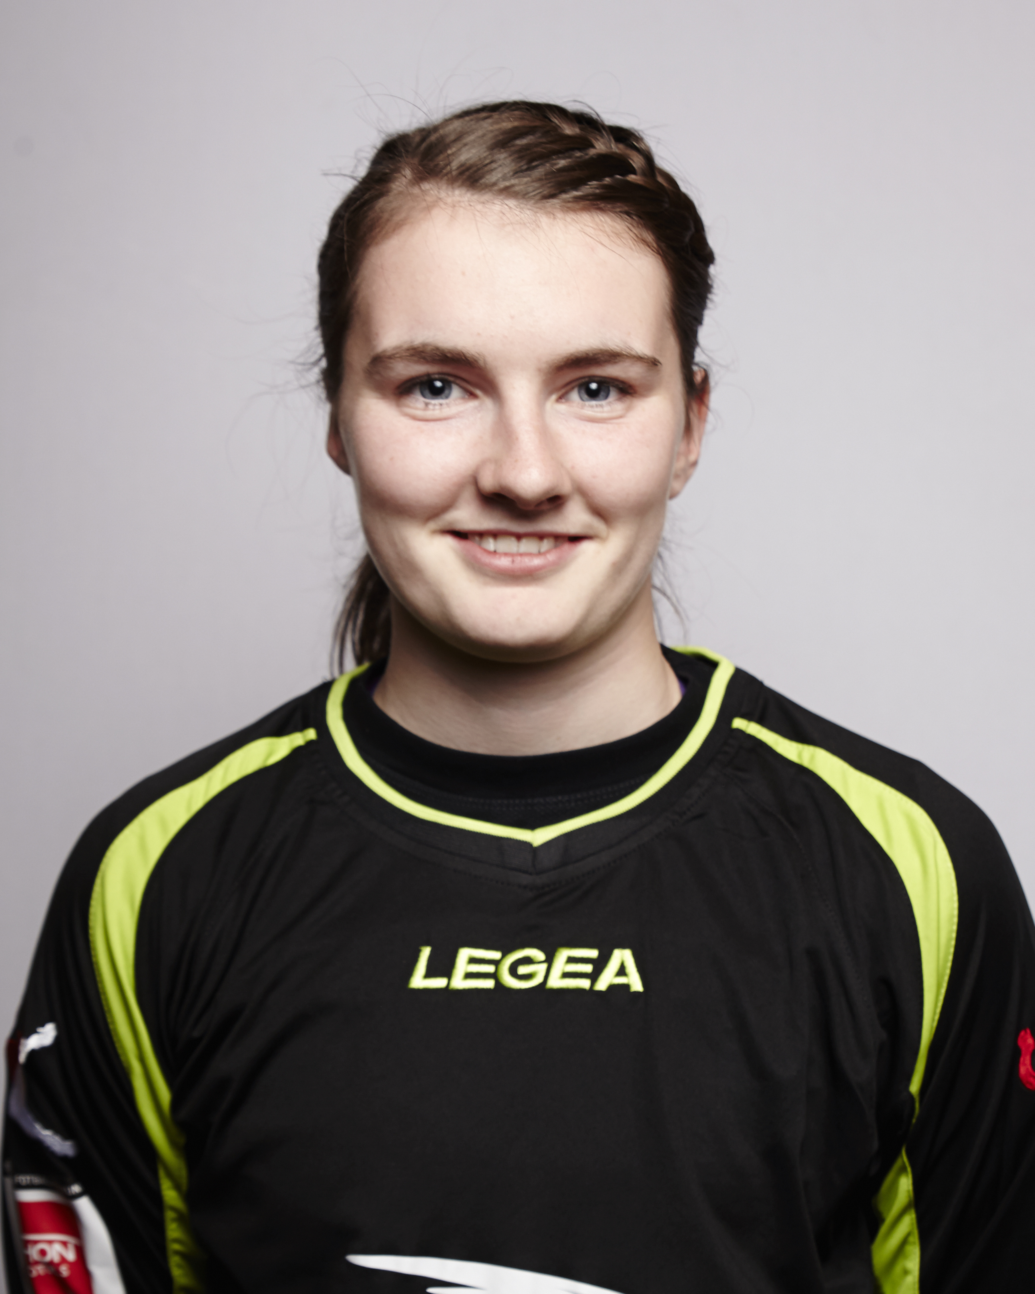  # 25  Goalkeeper
Bernt Knudsens vei 28b | DOB: 05-10-1995

Oslo, 1152
Tel: +4746461819 | Height: 5’ 7
Parents: Mette & Øyvind | Weight: 132 lbs.

College and Career Objective

My goal is to pursue a degree in school and reach my potential in soccer

Game Video - Siri 2.mov

Academic & Extra Curricular Club Team & Achievements
Class of 2014
Norges Toppidrettsgymnas (NTG)
Hans Burums vei 30
1357 Bekkestua

SAT Score N/A
Grade point N/A(((B1
Class rank N/A
Honors

Activities – Interests -Volunteer
- Goalkeeper coach for young talents in Oslo
- UEFA C license
Kolbotn Soccer Club (2010-2013)
Goalkeeper

Earlier achievements
Norwegian Youth National Teams (2010-now)
European Championships (2013)
Region Team (2009-2010)

Contacts & References

Brian Winners

United Soccer Academy
brian@unitedsocceracademy.org
440-666-8442

